Assignment 06 :

Use Group by clause with appropriate SQL functions to solve following queries.
Note: To solve below queries, use “sales” database

1. Write a query that counts the number of salespeople registering orders for each day. (If a salesperson has more than one order on a given day, he or she should be counted only once.).

SELECT odate, COUNT(DISTINCT snum)
FROM orders GROUP BY odate;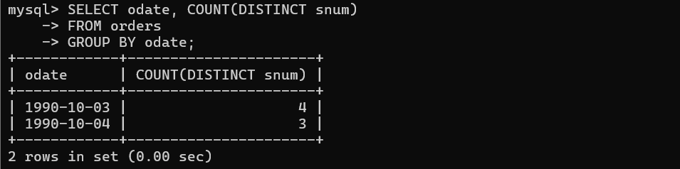

2. Write a query on the Customers table that will find the highest rating in each city. Put the output in this form: For the city (city), the highest rating is: (rating).

SELECT CONCAT(‘For the city’, city, ‘the highest rating is: ’, MAX(rating)) AS Rating
FROM customers
GROUP BY city;

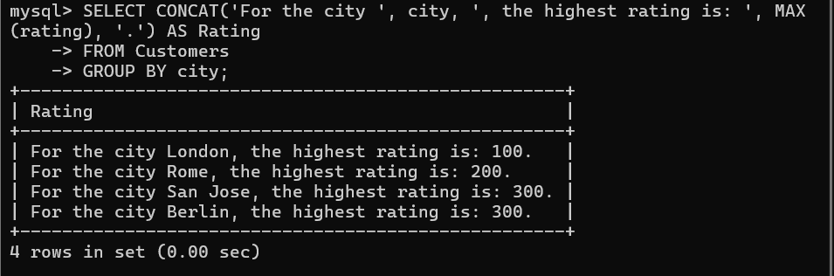

3 Write an SQL query to calculate the total order amount for each day and display the results in descending order of total orders.

SELECT odate, SUM(amt) FROM orders
GROUP BY odate
ORDER BY SUM(amt) DESC;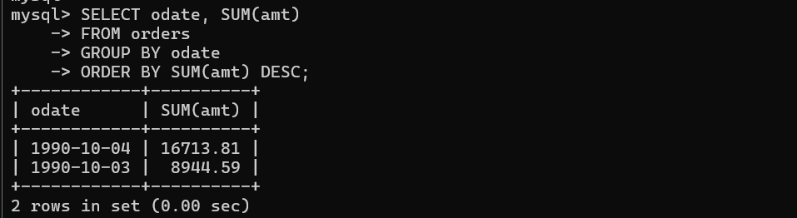

4. Write a query that selects the total amount in orders for each salesperson for whom this total is greater than the average amount of the order in the table. (Note Use the average amount value directly →2565.84)

SELECT snum, SUM(amt) AS total
FROM orders
GROUP BY snum
HAVING total > 2565.84;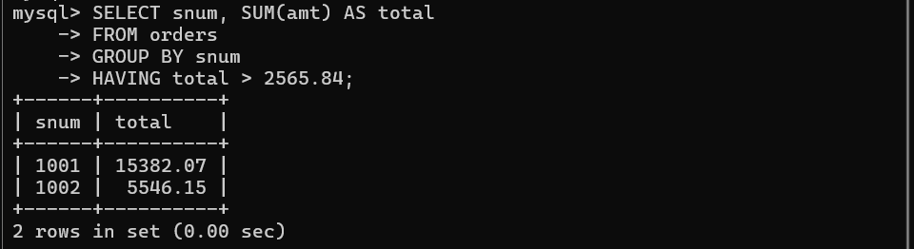

5. Write a query that selects the highest rating in each city.

SELECT city, MAX(rating) FROM customers
GROUP BY city;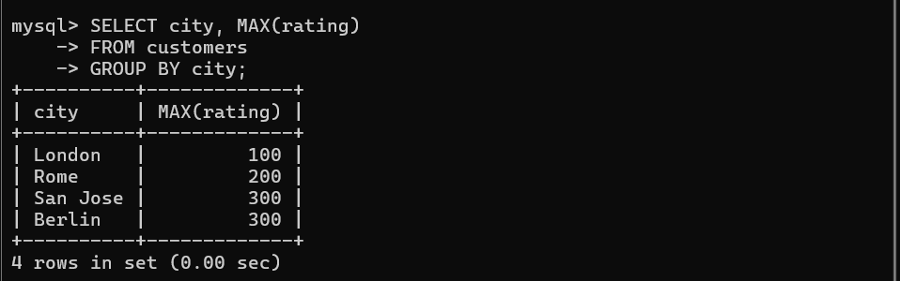
6. Retrieve the maximum order amount for each salesperson from the orders table, including only those orders whose value exceeds Rs. 3000.

SELECT snum, MAX(amt) FROM orders
GROUP BY snum
HAVING MAX(amt) > 3000;

7. Write an SQL query to find the smallest order placed by every customer.

SELECT cnum, MIN(amt) FROM orders
GROUP BY cnum;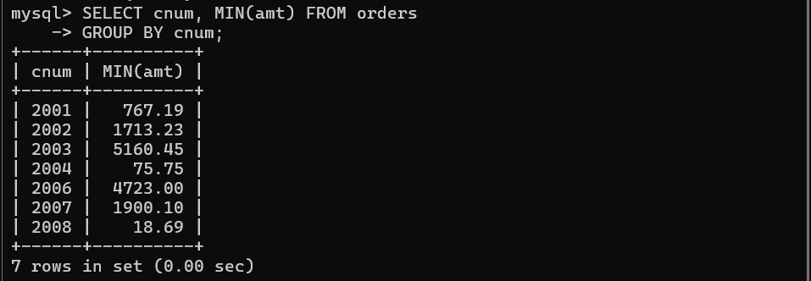

Note: To solve below queries. use “hr” database

1. Display manager ID and number of employees managed by the manager.

SELECT manager_id, COUNT(employee_id) FROM employees
GROUP BY manager_id;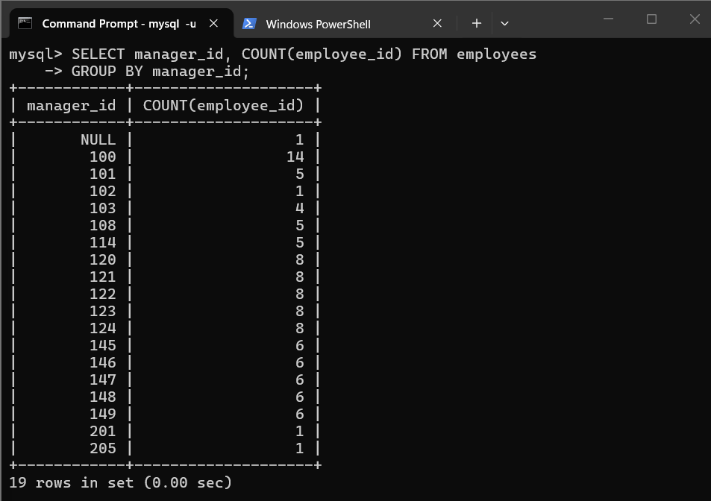

2. Display the country ID and number of cities we have in the country.

SELECT country_id, COUNT(city) FROM locations
GROUP BY country_id;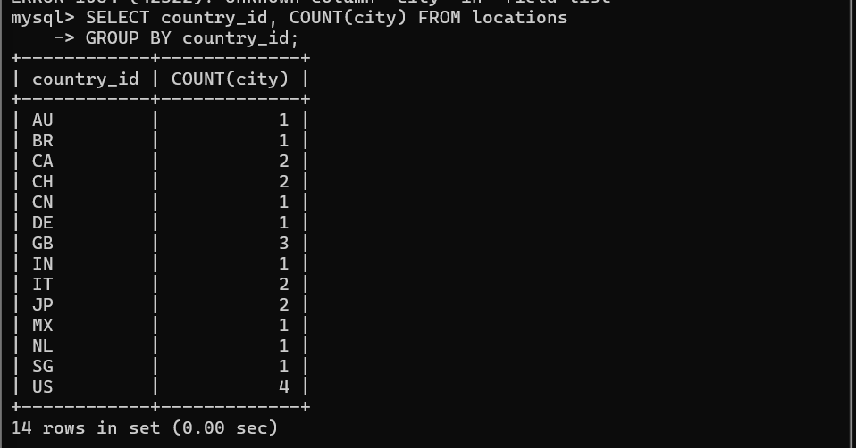

3. Display average salary of employees in each department who have commission percentage.

SELECT department_id, AVG(salary)
FROM employees
WHERE commission_pct IS NOT NULL
GROUP BY department_id ;

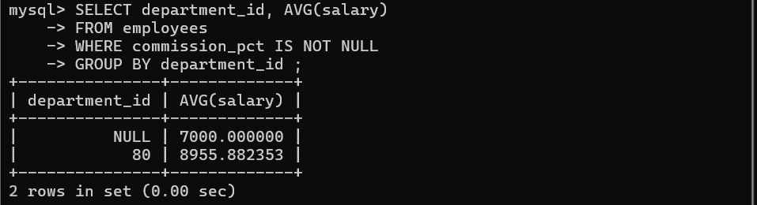

4. Display job ID, number of employees, sum of salary, and difference between highest salary and lowest salary of the employees for each job.

SELECT job_id, COUNT(employee_id), SUM(salary),
MAX(salary) - MIN(salary) AS difference
FROM employees
GROUP BY job_id;

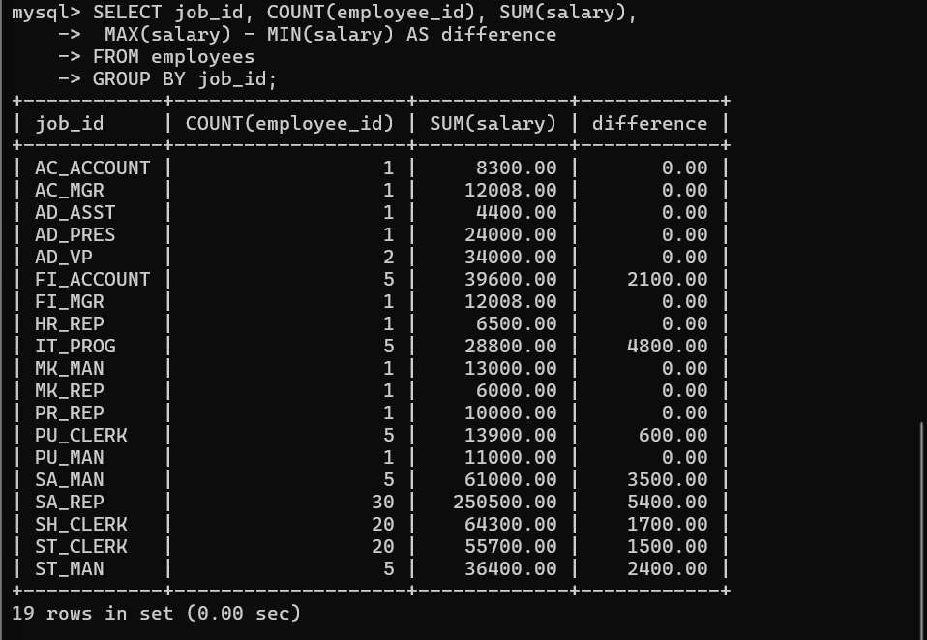

5. Display job ID for jobs with average salary more than 10000.
SELECT job_id, AVG(salary) FROM employees
GROUP BY job_id HAVING AVG(salary) > 10000;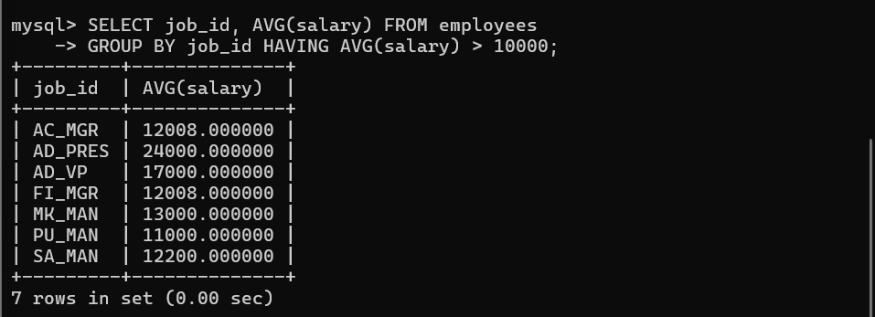

6. Display the years in which more than 10 employees joined.

SELECT YEAR(hire_date), COUNT(employee_id)
FROM employees
GROUP BY YEAR(hire_date)
HAVING COUNT(employee_id) > 10;


7. Display departments in which more than five employees have commission percentage.

SELECT department_id, COUNT(employee_id)
FROM employees
WHERE commission_pct IS NOT NULL
GROUP BY department_id
HAVING COUNT(employee_id) > 5;

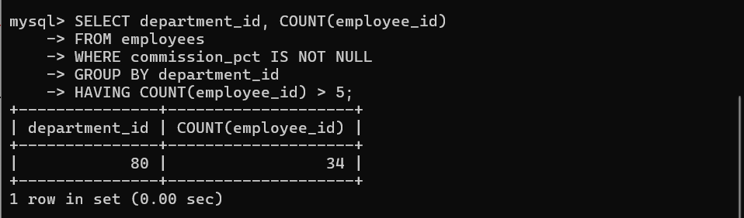

8. Display employee ID for the employees who did more than one job in the past.

SELECT employee_id, COUNT(job_id) FROM job_history
GROUP BY employee_id
HAVING COUNT(job_id) > 1;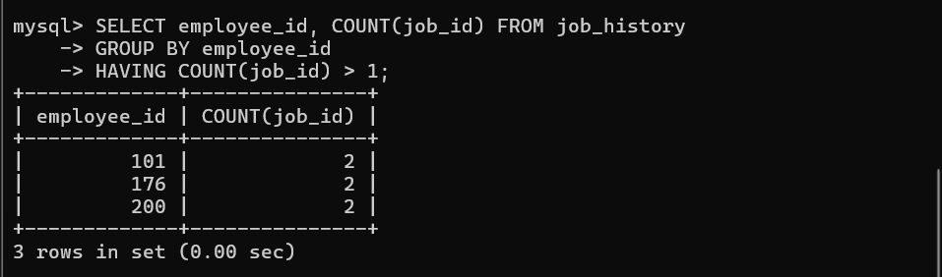

9. Display job ID of jobs that were done by 2 or more employees for more than 100 days individually.

SELECT job_id, COUNT(employee_id) FROM job_history
WHERE DATEDIFF(end_date, start_date) > 100
GROUP BY job_id
HAVING COUNT(employee_id) > 1;
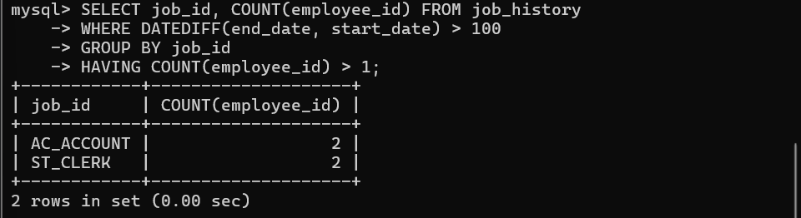

10. Display the department ID, year of hiring, and the number of employees who joined each department in each year.

SELECT department_id, YEAR(hire_date), COUNT(employee_id)
FROM employees
GROUP BY department_id, YEAR(hire_date)
ORDER BY department_id;

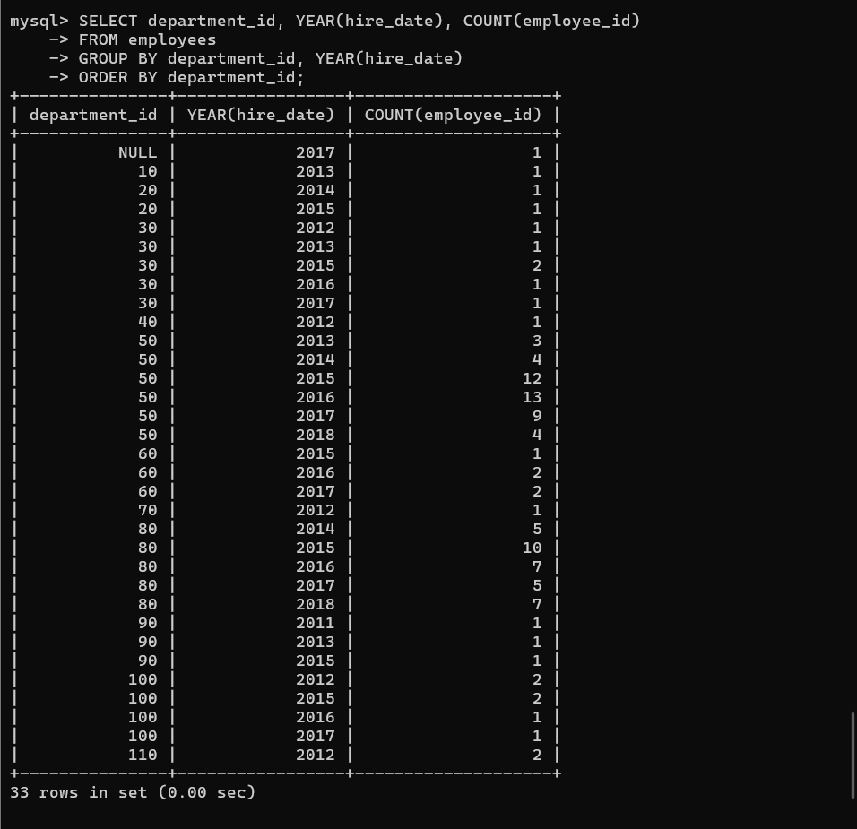

11. Display the count of employees joined in each month of the year 2017.
SELECT COUNT(employee_id), MONTHNAME(hire_date)
FROM employees WHERE YEAR(hire_date) = 2017
GROUP BY MONTHNAME(hire_date);
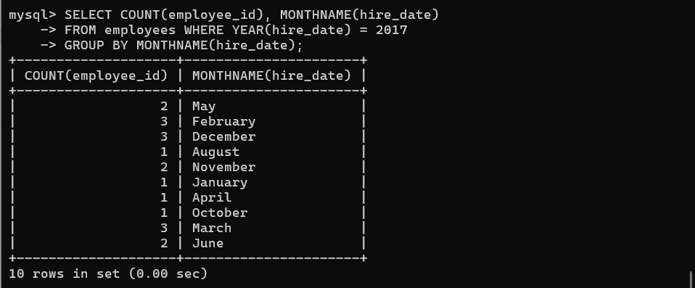

12. Display the details of departments in which the maximum salary is more than 10000.

SELECT department_id, MAX(salary)
FROM employees
GROUP BY department_id
HAVING MAX(salary) > 10000;


